Considerations for Restoring Annan Water (RAW)
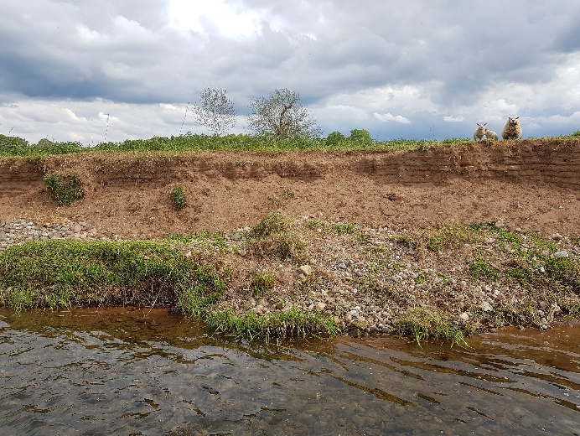
The river, waters and burns of the Annan are vital wildlife corridors through the landscape. If protected and improved, they can provide oases for a wide range of wildlife, both within the water and along the banks. These areas are not only crucial as habitat but also in contributing to air and water quality, carbon sequestration and natural river function. They can provide amenity value and enjoyment to people from all walks of life and can be a real asset to a community.

For the Annan to be in top condition, its banks should be free from excessive erosion and accommodate a diverse mixture of herbaceous plants, shrubs and trees extending well back from the bank. These areas, often referred to as ​‘buffer zones’, provide vital space between crops or grazing and the river, with benefits for land management as well as wildlife.

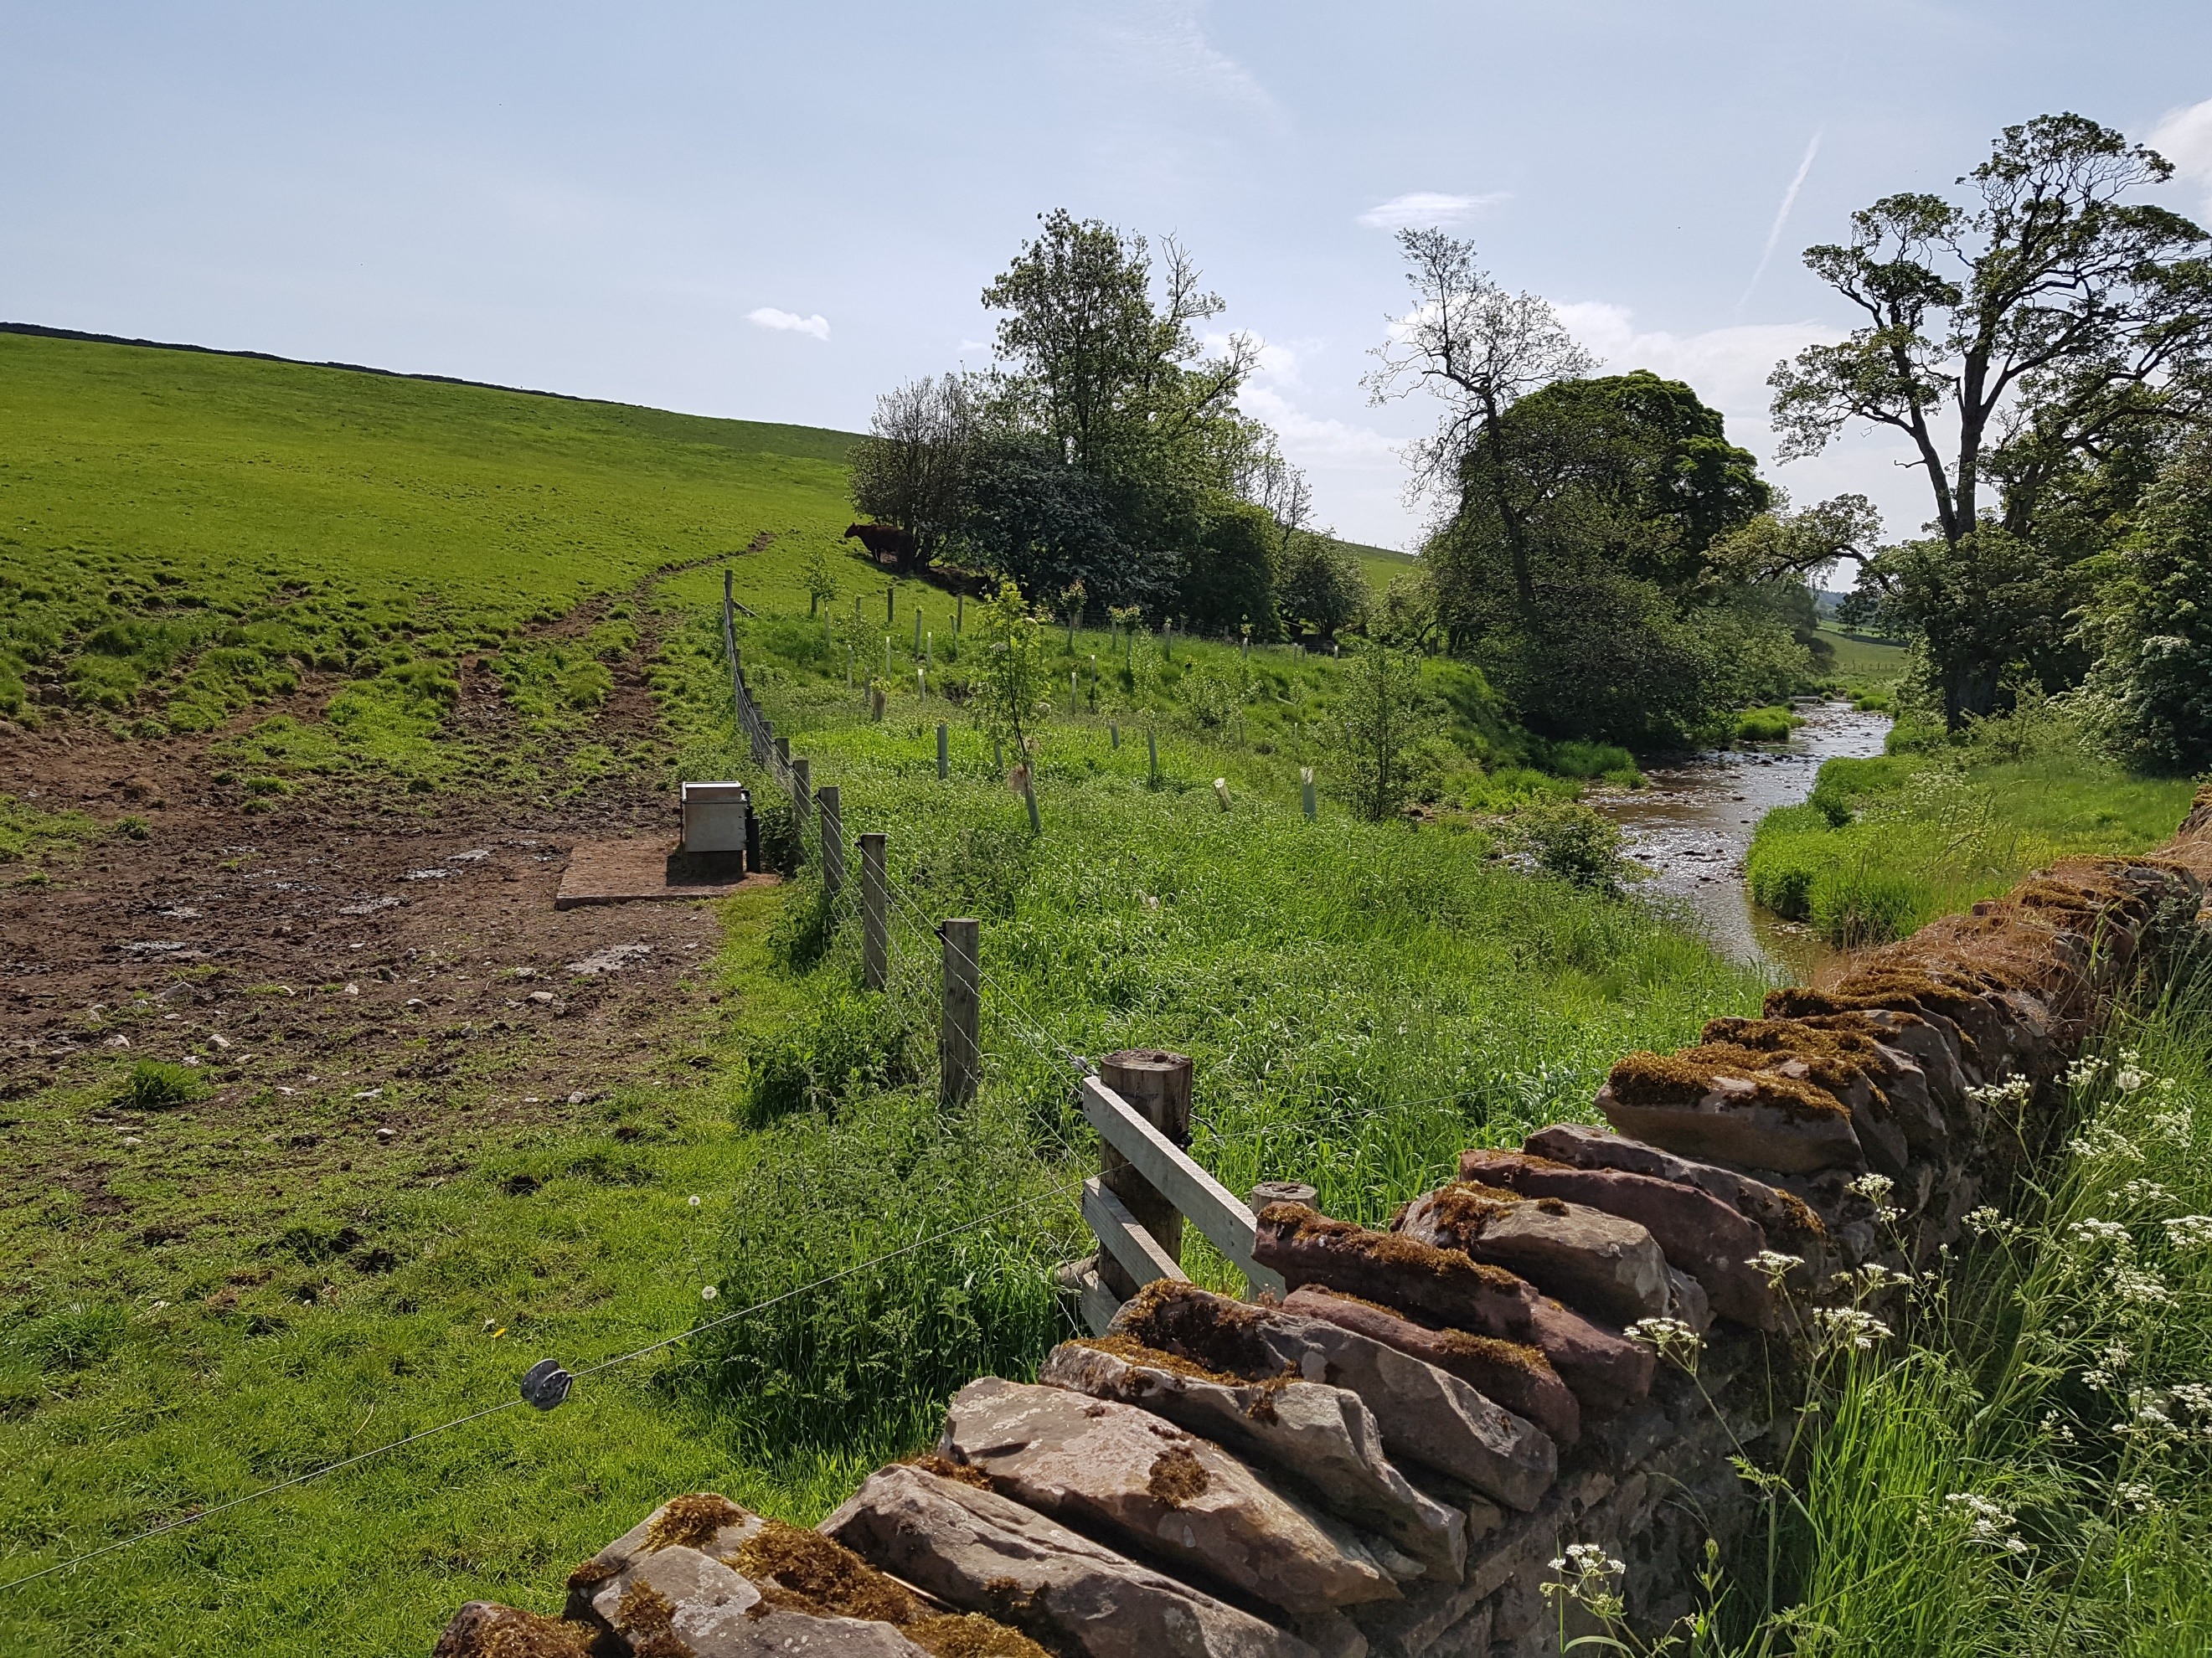
It is important to consider that what is perfectly acceptable management of agricultural land can be damaging to the banks of a watercourse, so buffer zones and fences are often vital in protecting rivers while maintaining the productivity of adjacent land. Without this buffer, runoff from arable fields and erosion caused by livestock can lead to increased nutrient inputs and siltation of the bed. When increased fine sediment enters a watercourse it deposited within the riverbed material, blocking the gaps in which invertebrates live and preventing the vital flow-through of water that is required to incubate the eggs od lamprey, trout and salmon eggs that are laid within the gravel. Clearly, the loss of land through erosion is also unfavourable to landowners, so tackling excessive erosion is in everyone’s interest.

Buffer zones play a pivotal role in restoring the natural regeneration of saplings and herbaceous vegetation along riverbanks, both of which are inhibited by grazing. They thereby help to safeguard the future of riverside trees, ensuring the vital functions they provide through bank stabilisation, shade to moderate summer water temperatures, and general habitat creation.

Invasive non-native species (INNS) pose an increasing threat to the Annan that requires action before they become unmanageable, and they should be tackled alongside creation of any buffer zones. The source of species like Japanese knotweed, giant hogweed and Himalayan balsam (among others) on the catchment must be identified and eradicated, to ensure that they are not allowed to spread and dominate native plant species. American mink are present on the catchment and pose a treat to many native species through predation and require action.
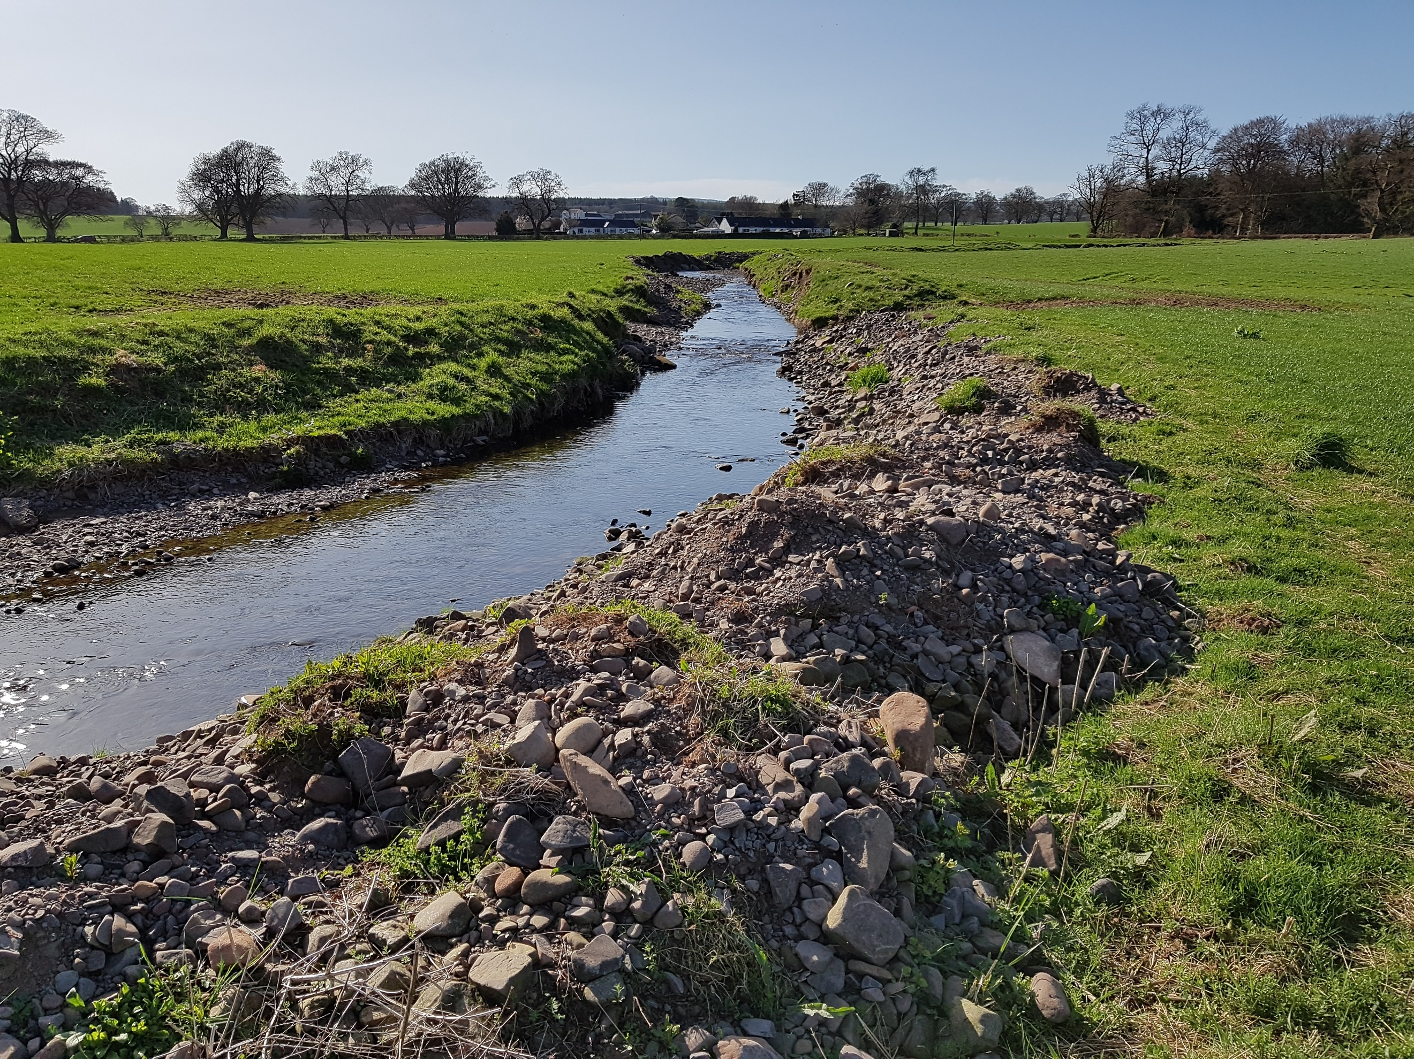
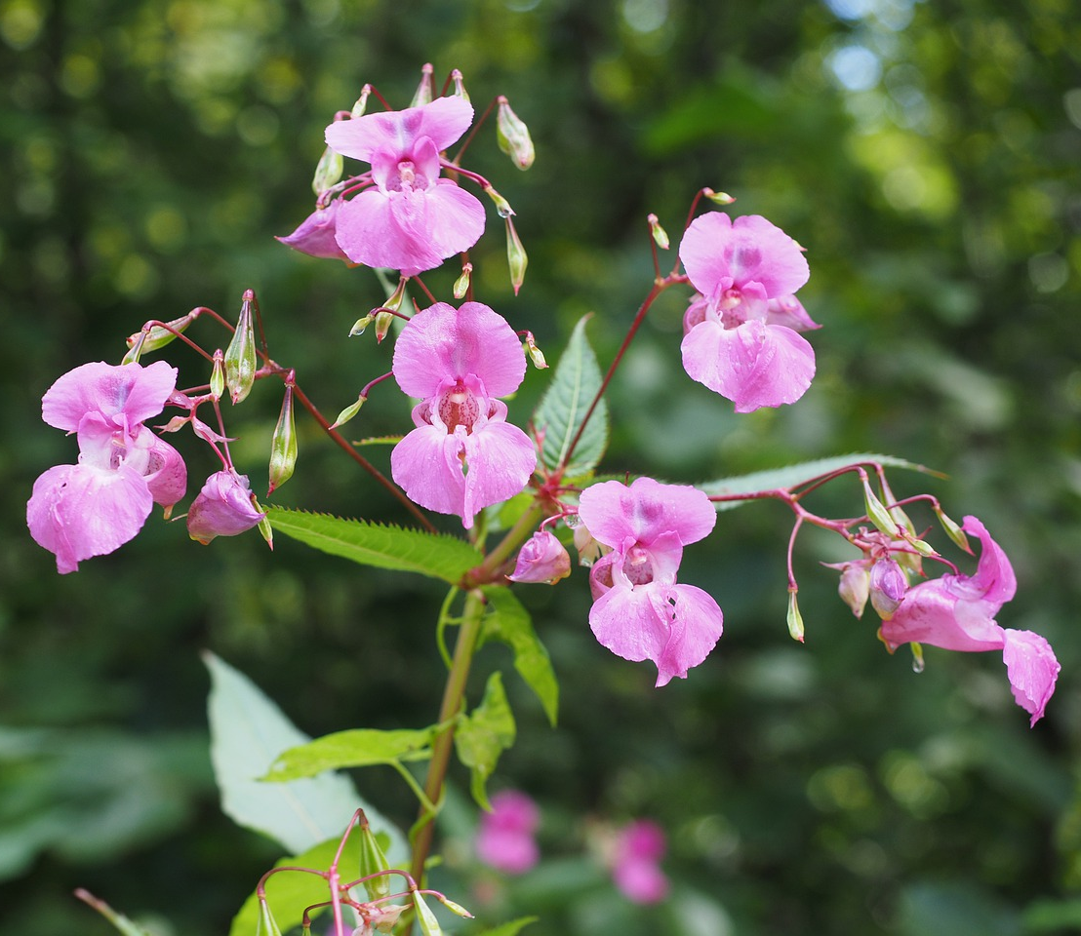Himalayan balsam
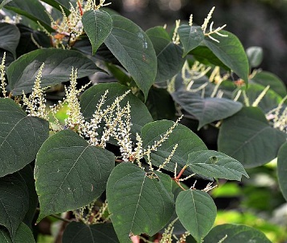Japanese knotweed
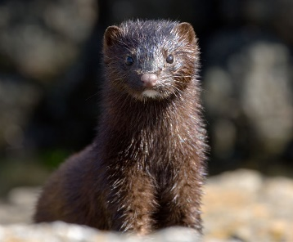American mink
Many areas of the Annan catchment remain impacted by channel maintenance and modification, with significant lengths dredged or realigned from their natural course and others fragmented by man-made structures like weirs and culverts. These modifications degrade form and function of a river, reducing flow diversity, inhibiting the formation of natural pools and riffles, and reducing the accessibility and quality of habitat both within the channel and along the banks.
Human rubbish is an ongoing issue, with some people seeing the river as a disposal service for rubbish and garden or household waste. This not only degrades habitat but also the aesthetics of an area, reducing enjoyment for other people and encouraging further abuse, as the river appears neglected. A healthy, clean river on the other hand engenders a sense of local pride and care for the environment.
A list of priority actions to optimise habitat for fish and other wildlife, and Restore Annan Water might include:
- Excluding livestock from the riverbanks
- Reducing nutrient inputs
- Removing redundant man-made structures and artificial bank revetment
- Reinstating natural meanders and natural flow diversity
- Preventing unnecessary dredging and channel modification
- Reducing the amount of litter entering the watercourse
- Addressing the various non-native species
This is just a brief overview of the challenges facing our rivers, further information on river habitat can be found on the Wild Trout Trust website Rivers Resource Hub - https://www.wildtrout.org/content/rivers-resource-hub

